GGL System report

(<http://ggl.neotural.com/login>)

1. Admin – Approval booking – Please for information Approval Booking adjusted by information booking details (sort by category)

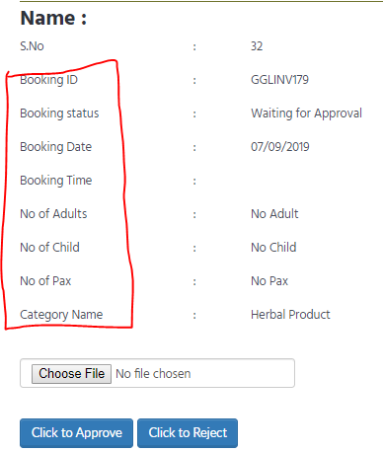  
2. [www.gglway.com](http://www.gglway.com) – Contact – Please add for receive an any Message in GGL to email : globalgains49@gmail.com - cannot click send

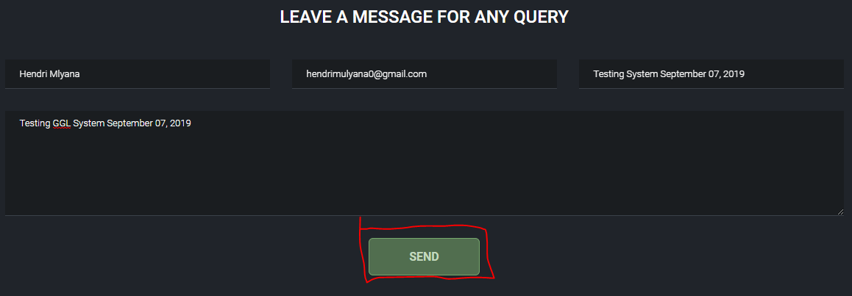

**Completed and Team will test and give the feedback**

GGL Mobile Apps report

1. Member – Withdrawl – Cannot Click Withdrawl

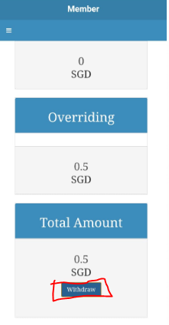

**It is working fine in server, we have tested several time , Kindly test proper ally and let us know**

2. Member – Investment – Payment Option – Online Payment – Cannot Continue to Checkout

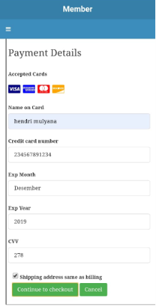

**Online payment is not working , So It is not issue , We have not yet done online payment as of now. Please check with Magin.**

3. Member – Investment – Payment Option – Wire Payment – Please for bank account details entered into the wire transfer column

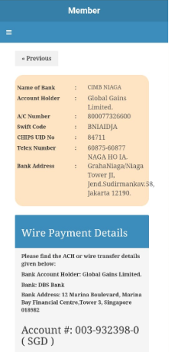

**It is completed and Please check**

**Additionally we are working on New Look UI Changes, 3 Weeks timeframe , So expected to close only by 5th Oct 2019**